1. checkin, restaurant 데이터를 활용하여 인기 요일/시간대 분석

* 소스코드

create table checkin_detail

stored as parquet as

select

business_id

, 'monday' as dayofweek

, t1.k as tm

, t1.v as cnt_checkin

from

checkin2 lateral view explode(time.monday) t1 as k, v

;

insert into checkin_detail select business_id, 'tuesday' as dayofweek, t1.k as tm, t1.v as cnt_checkin from checkin2 lateral view explode(time.tuesday) t1 as k, v;

insert into checkin_detail select business_id, 'wednesday' as dayofweek, t1.k as tm, t1.v as cnt_checkin from checkin2 lateral view explode(time.wednesday) t1 as k, v;

insert into checkin_detail select business_id, 'thursday' as dayofweek, t1.k as tm, t1.v as cnt_checkin from checkin2 lateral view explode(time.thursday) t1 as k, v;

insert into checkin_detail select business_id, 'friday' as dayofweek, t1.k as tm, t1.v as cnt_checkin from checkin2 lateral view explode(time.friday) t1 as k, v;

insert into checkin_detail select business_id, 'saturday' as dayofweek, t1.k as tm, t1.v as cnt_checkin from checkin2 lateral view explode(time.saturday) t1 as k, v;

insert into checkin_detail select business_id, 'sunday' as dayofweek, t1.k as tm, t1.v as cnt_checkin from checkin2 lateral view explode(time.sunday) t1 as k, v;

;

select dayofweek, count(1) from checkin_detail group by dayofweek

;

-- 요일별

create table dm_checkin_dayofweek

stored as parquet as

select

a.name

, b.dayofweek

, sum(b.cnt_checkin) as number_checkin

from

restaurant a

, checkin_detail b

where

a.business_id = b.business_id

group by a.name

, b.dayofweek

;

-- 시간대별

create table dm_checkin_time

stored as parquet as

select

a.name

, b.tm

, sum(b.cnt_checkin) as number_checkin

from

restaurant a

, checkin_detail b

where

a.business_id = b.business_id

group by a.name

, b.tm

;

--결과 테이블

create table result1_output1

stored as parquet as

select

a.*

from

(

select

dayofweek

, name

, number_checkin

, row_number() over(partition by dayofweek order by number_checkin desc) as rn_dayofweek

from

dm_checkin_dayofweek

) a

where

a.rn_dayofweek <= 10

;

--요일별 checkin 5위까지 출력

select * from result1_output1 where rn_dayofweek <= 5 order by dayofweek, rn_dayofweek;

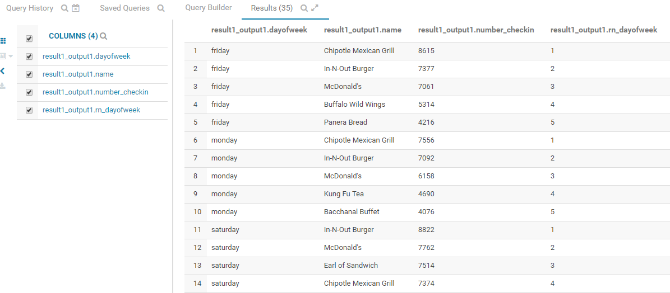

-- 일요일에 checkin인기 업체

select * from result1_output1 where dayofweek = 'sunday';

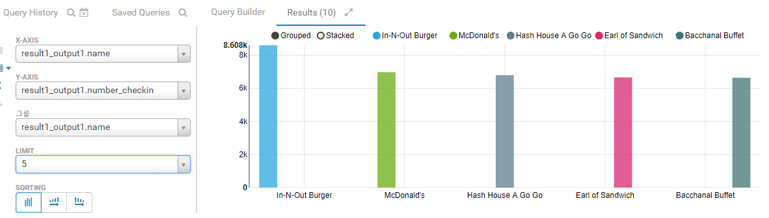

-- 일요일 checkin 1위 업체의 시간대별 checkin 현황

select

a.name

, a.tm

, a.number_checkin

from

dm_checkin_time a

, result1_output1 b

where

a.name = b.name

and b.dayofweek = 'sunday'

and b.rn_dayofweek = 1

;

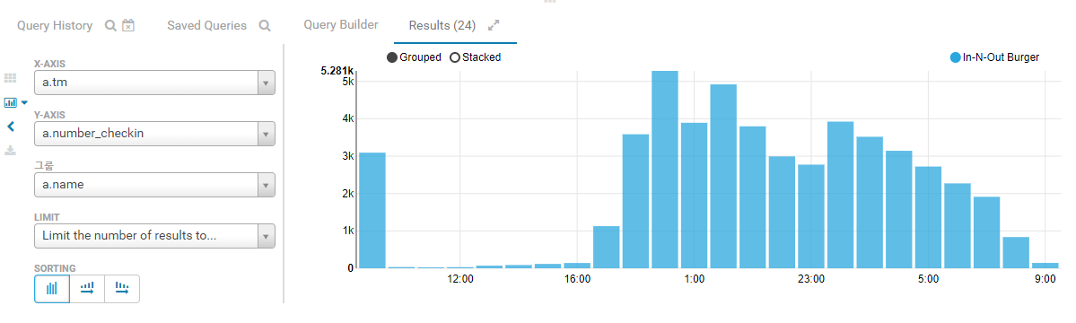

2. users 테이블에서 friend가 가장 많은 상위 100명 user의 업체 분석

--user별 friend별 temp 테이블 생성

create table users_t1

stored as parquet as

select

user_id

, t1.friend

from

users2 lateral view explode(friends) t1 as friend

;

drop table power_users purge;

--friend가 많은 상위 100명(power user) 테이블 생성

create table power_users

stored as parquet as

select

a.user_id

, b.name

, b.review_count

, b.useful

, b.cool

, b.funny

, b.fans

, number_friend

, row_number() over(order by number_friend desc) as rn

from

(

select

user_id

, count(friend) as number_friend

from

users_t1

group by user_id

) a

, users2 b

where

a.user_id = b.user_id

limit 100

;

drop table result2_output purge;

-- power user가 리뷰를 남긴 레스토랑 분석

create table result2_output

stored as parquet as

select

c.name

, min(b.stars) as min_stars

, max(b.stars) as max_stars

, max(c.review_count) as review_count

, count(a.user_id) as number_user

from

power_users a

, review2 b

, restaurant c

where

a.user_id = b.user_id

and b.business_id = c.business_id

group by c.name

;

-- 파워유저가 최저,최고 별점이 4점 이상인 레스토랑 상위 10위

select

name

, max_stars as stars

, review_count

, number_user

from

result2_output

where

max_stars >= 4

and min_stars >= 4

order by number_user desc

limit 10

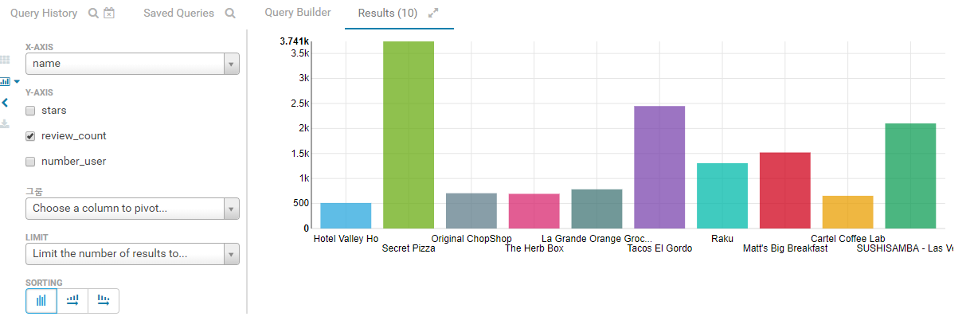

3. 리뷰의 useful을 사용해서 best 10, worst 10 레스토랑을 보여줌

%pyspark

df_review = spark.sql("select business_id, stars, sum(useful) as number_useful from review2 where stars in (1,5) group by business_id, stars having sum(useful) >= 1000")

df_review.registerTempTable("v_review")

%pyspark

df_restraunt = spark.sql("select business_id, name, stars, review_count from restaurant")

df_restraunt.registerTempTable("v_restraunt")

%sql

select

case when t.stars = 1 then '2.Worst'

when t.stars = 5 then '1.Best'

else 'None' end as top

, t.rn

, t.name

, t.number_useful

, t.restraunt_stars as avg_stars

from

(

select

a.stars

, b.stars as restraunt_stars

, b.name

, a.number_useful

, row_number() over(partition by a.stars order by a.number_useful desc) as rn

from

v_review a

, v_restraunt b

where

a.business_id = b.business_id

) t

where

t.rn <= 10

order by 1

